**Lab - Creating Mapped Drive Using Group Policy**

**Overview**

In this lab, you will learn how to map a drive using group policy inside their Active Directory domain. Mapping network drives are one of the most common jobs for a network administrator. Normally, this is done using a batch file or a script. In the past, we would have used a script, but there is a group policy setting that can save us the scripting effort.

We begin by creating a new container up inside of Users and Computers. In the example, I have created a new container and called it HR. Inside this container, I created another container cared HR_Users. Inside my HR_Users container, I created 2 new users and HR_Users group which I added the two HR user to.

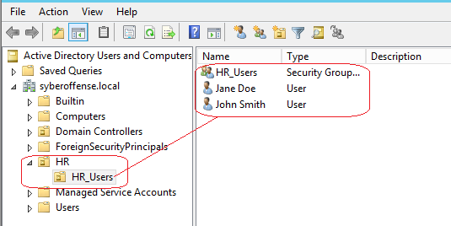

You’re free to make any new container or use an existing container and users for this lab.

We next need to create a network share we would like to map out to the HR_Users. To do this, I open the C: Drive and create a folder called share. I then right-click on the new shared folder and select **Properties** from the context menu.

**Create the share**

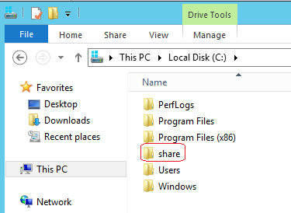

Right, and select **Properties** from the context menu.

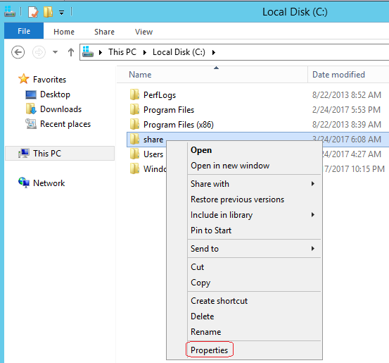

Under properties, open the share tab and click on the share button.

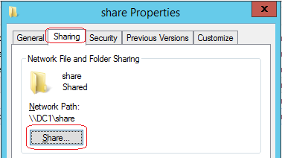

Add the group or users you want to have access to the mapped drive folder. Click on the share button and then done.

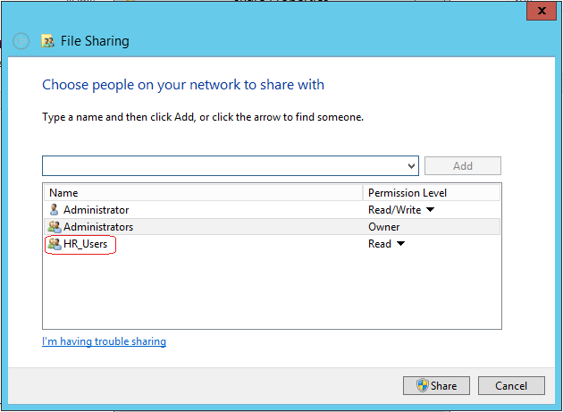

Closeout the shared folder properties and close out the local disk C: window.

Open Server Manager and go to Tools, and open the Group Policy Management Snapin

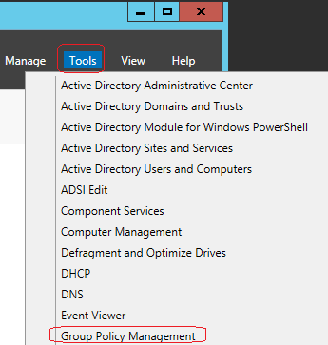

Under Group Policy Management, expand the name of your domain and select the container to add your map drive GPO to. Right-click on the container and select, “Create a GPO in the domain and link it here.” This creates the GPO.

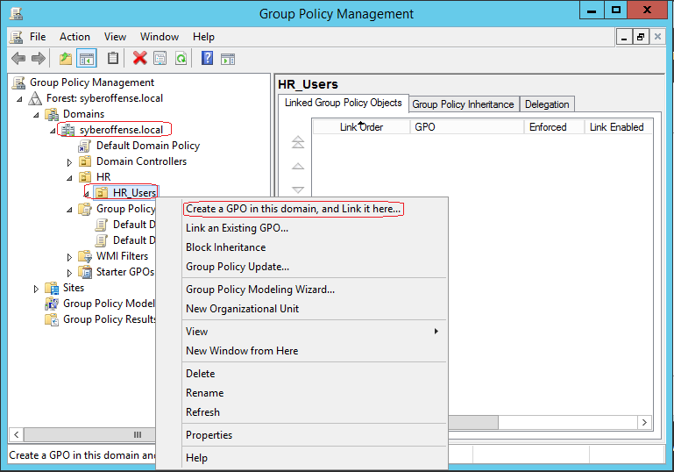

Expand the container and find the GPO you just created, right-click on the GPO and from the context menu, select edit.

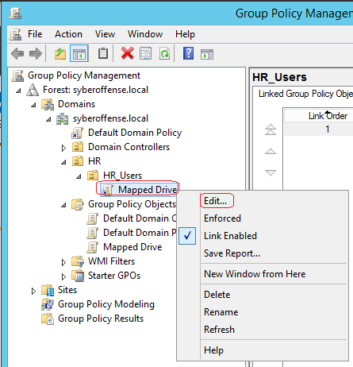

This brings up the settings for the GPO. Under User Configuration, open the preferences, and then open Windows Settings. Find Drive Maps settings, right-click and select new and select Mapped Drive.

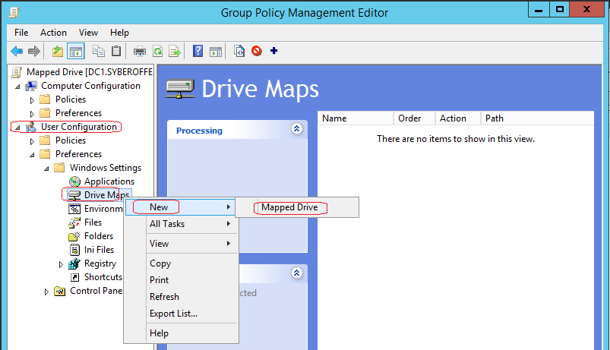

Under the New Drive Properties, do the following:

* Under action, select create.
* Under location type in the network path to the share, we created earlier.
* Under Label as, give the share a user-friendly name.
* Next to Use, pull down the windows and select a drive letter.
* Under Hide/Show this drive, select show this drive.
* Click Apply, OK.

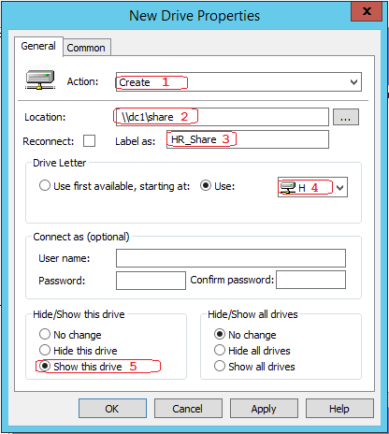

Open your Windows 7 client. Log on as one of the users that resides in the container to which you applied the new GPO for a mapped drive.

Open a command prompt and type, gpupdate /force.

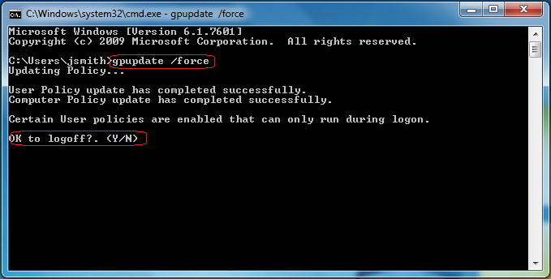

Log off and log back on if needed.

Go to Start, open Computer and see if you have a mapped drive.

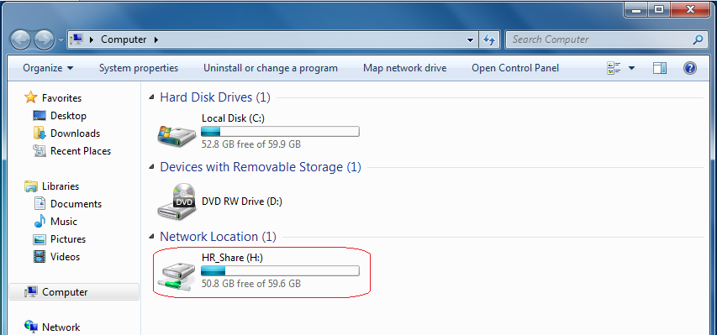

End of the lab!